Programming for Artificial Intelligence

Project Title:
TrackWise Expense Tracker
Tools & Techniques:
- GUI Development Tools And libraries
- Tkinter (Core GUI)
- Tkk (Treeview for tabular display of data)
- Tkcalander (Calander widget)
- Messagebox (Display Alerts and pop ups)
- Askstring (Prompt input)
- Filedialog (Import & Export of CSV)
- Data Handling & Logic Techniques:
- List of dictionaries
- Defaultdict from collections
- CSV module
- Datetime
- Hashlib
- Exception handling
- Input validation
- Password verification

- Visualization and Analytics:
- Matplotlib.pyplot (Used for pie, bar and line charts)
- Numpy (For the mean and averages of data)

- Software Design and Techniques:
- Concept of OOP For the classes to show up as different pages as a modular design
- Frame Based Multi-paged layout
- Event Driven and programming for the widget response via bounded functions
- Modular Functions in the tree-setup
- Dynamic Tree view which is auto updated based on the actions like insertion deletion filtration and updating
Description:
TrackWise is a GUI-based personal expense tracker built using Python’s tkinter library. It allows users to securely log in, add, view, filter, update, delete, and analyze their expenses using a sleek, dark-themed interface. Expenses are stored as dictionaries in a list and can be imported/exported via CSV.
Key features include:
- User Authentication (password hash-based login)
- Modular Page Navigation (Home, Add, View, Filter, Calendar, Charts, etc.)
- Date & Category Filtering
- Monthly and Pie Chart Visualization using matplotlib
- Calendar View & Recurring Expense Alerts
- CSV Import/Export for data portability
- TreeView Tables for structured display
- Dark UI with custom icons for enhanced UX
Built with object-oriented design, the application ensures maintainability and scalability. It uses datetime, collections, hashlib, and numpy to support robust data operations and analytics.

Output of code:
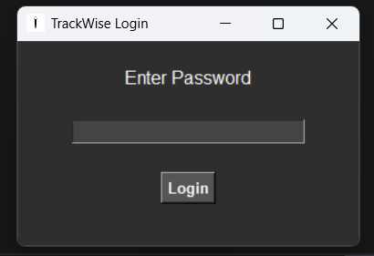
When we run our code the authenticator works and ask for the password which we set and can also be changed latter
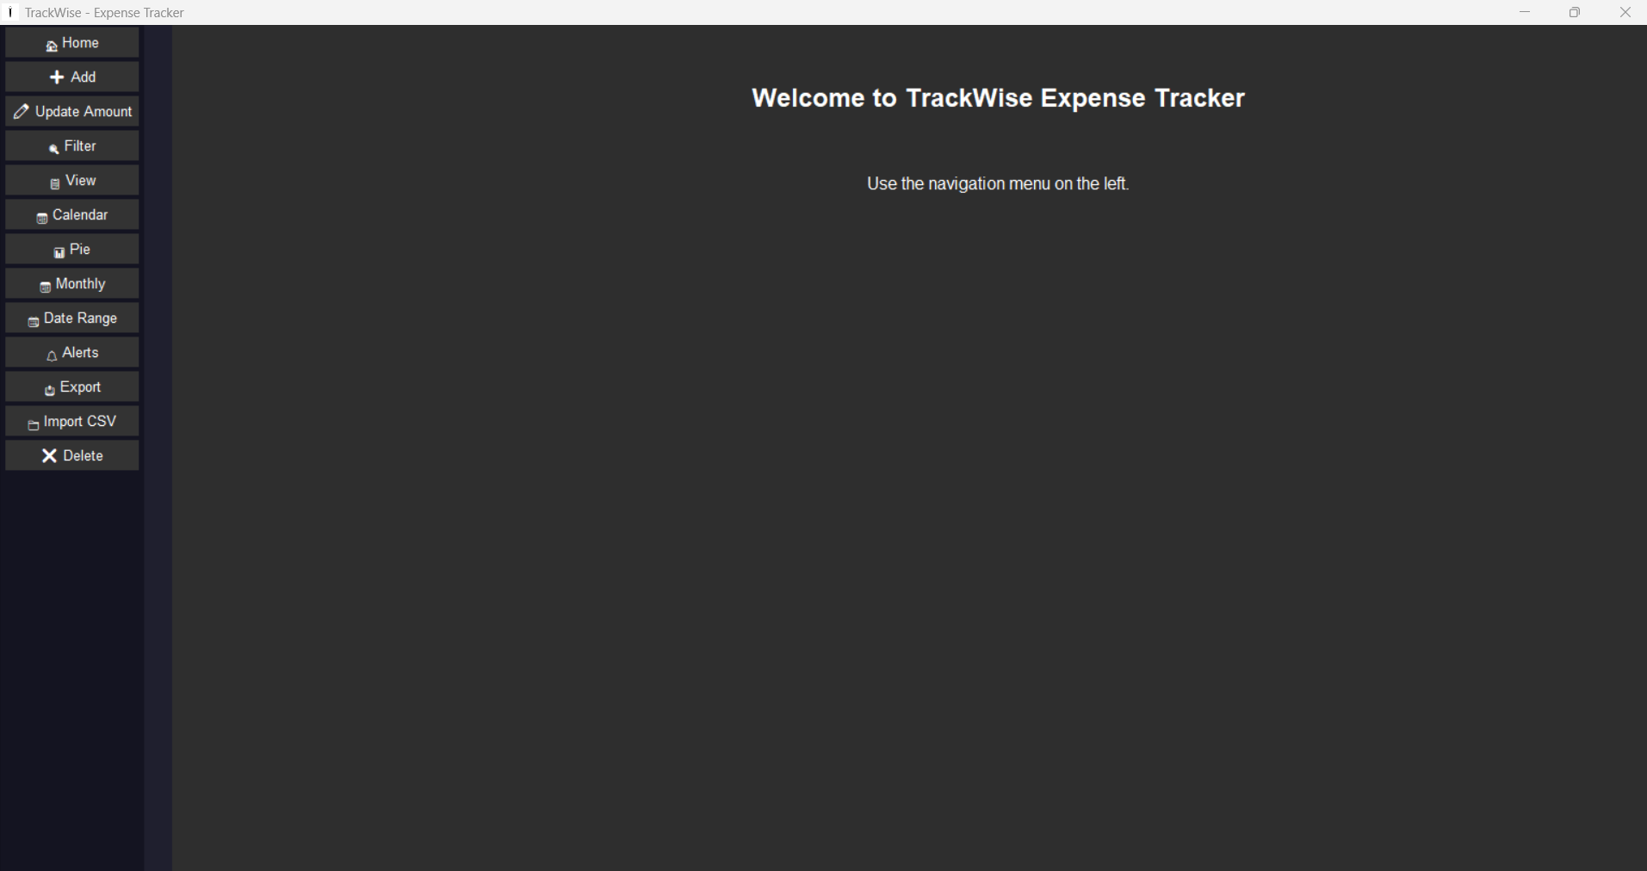
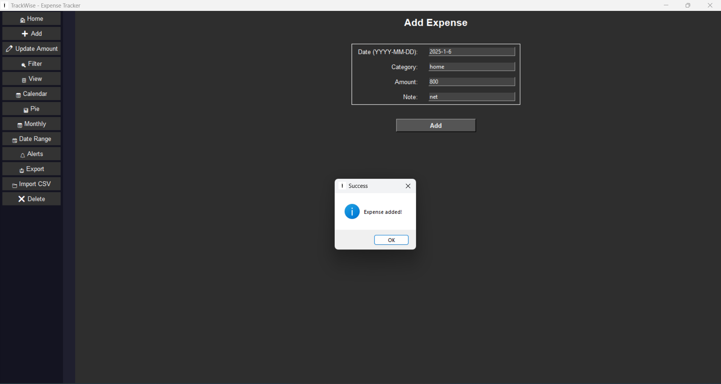
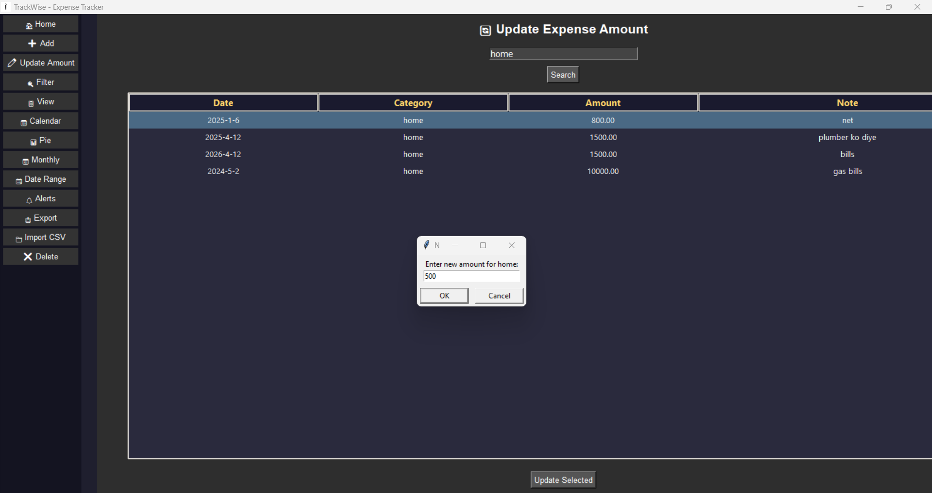
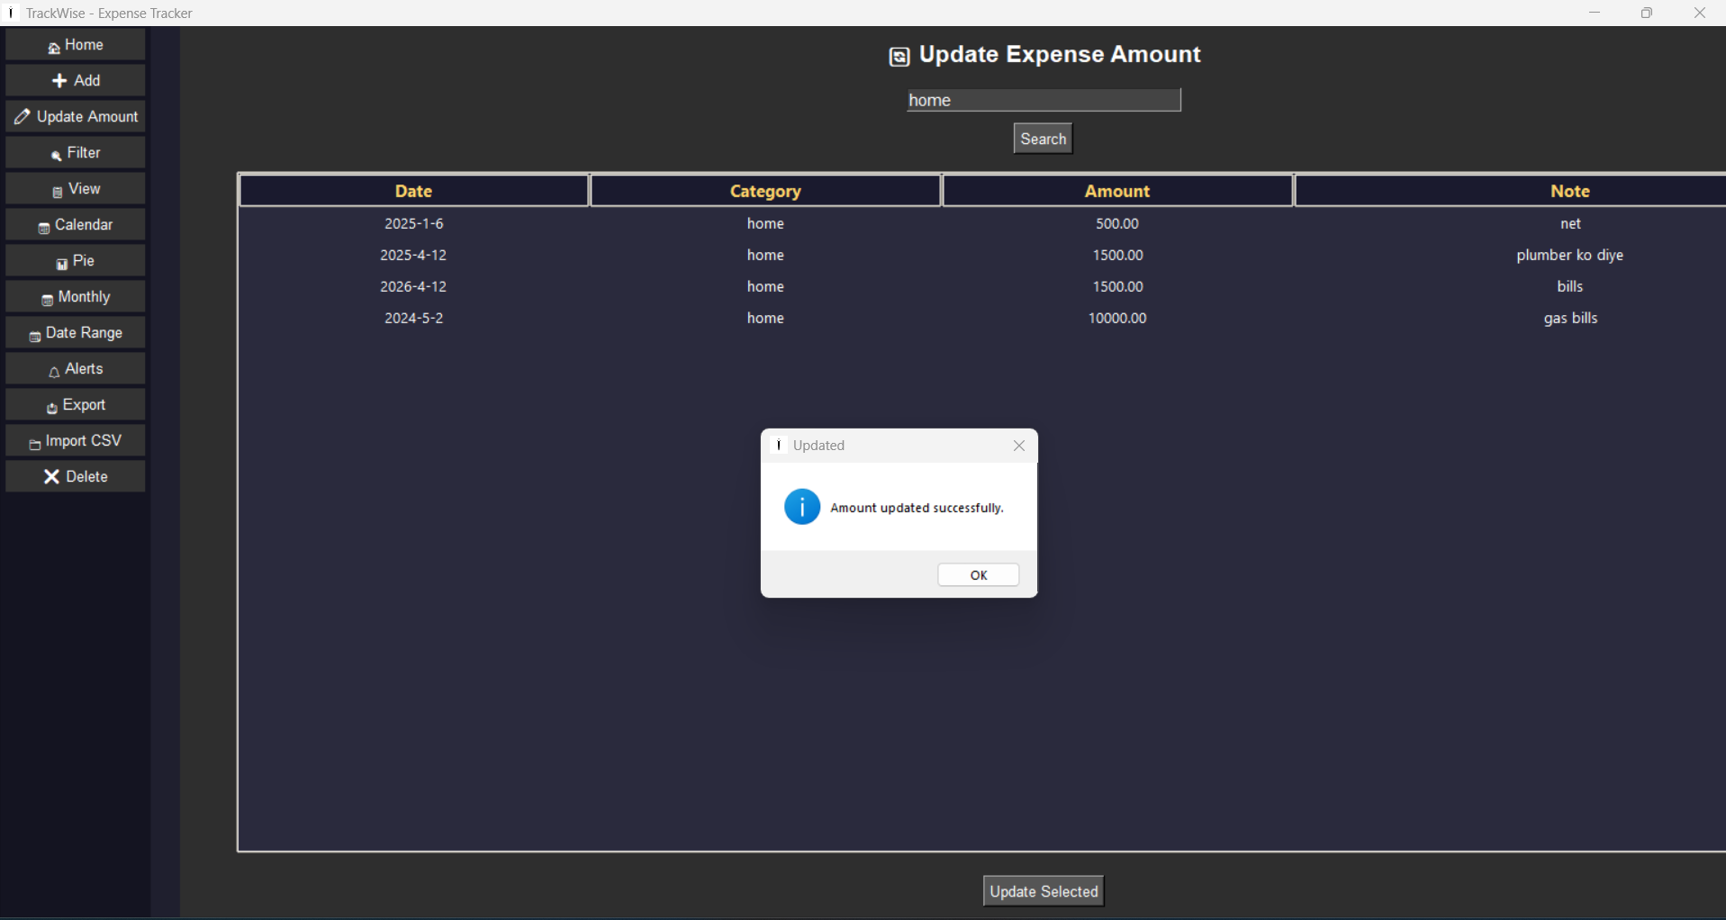
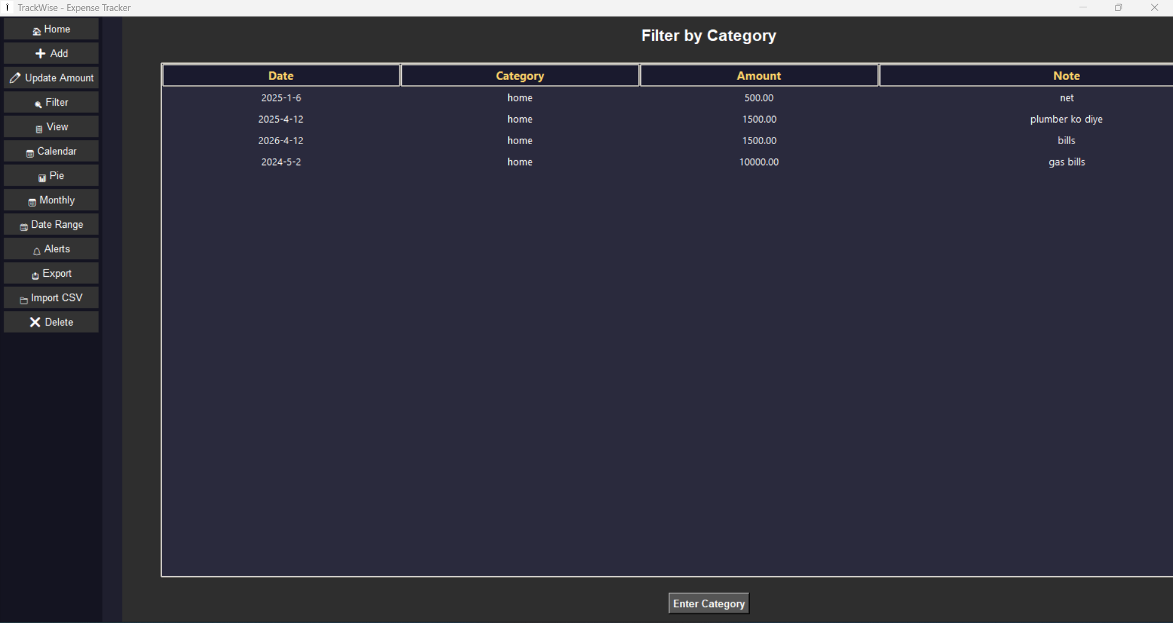
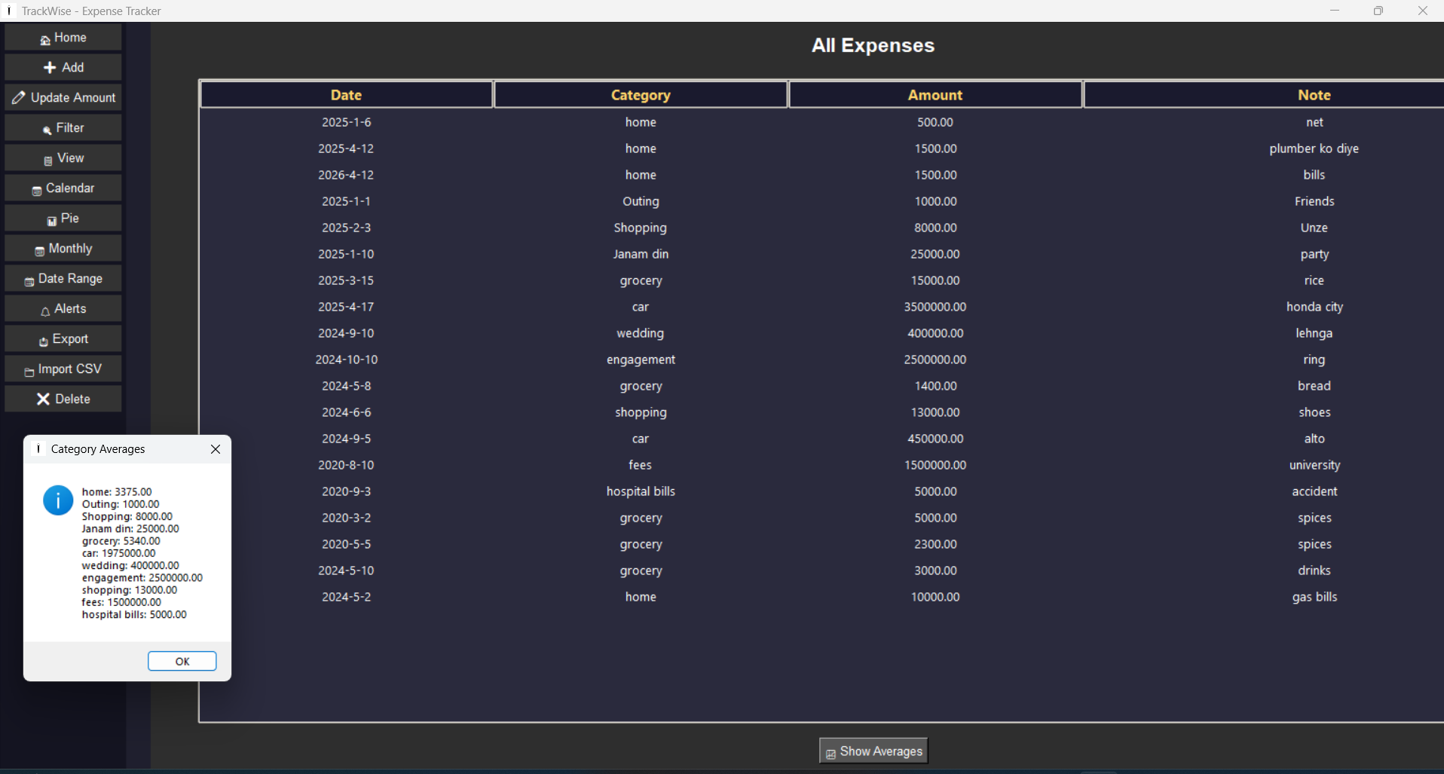
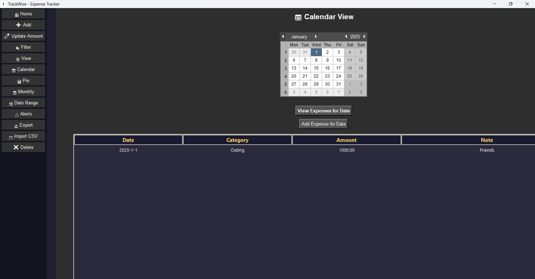
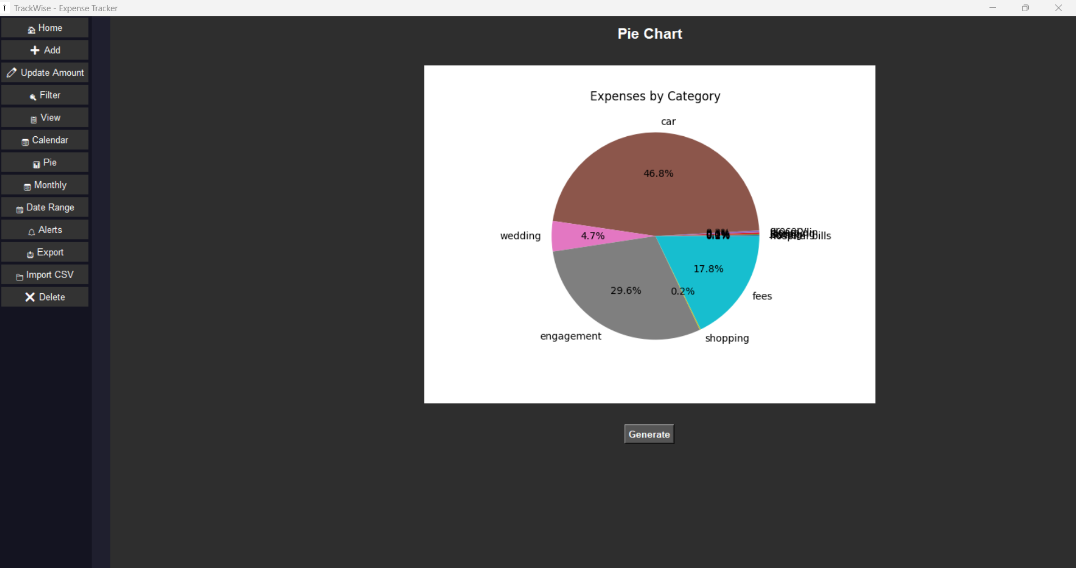
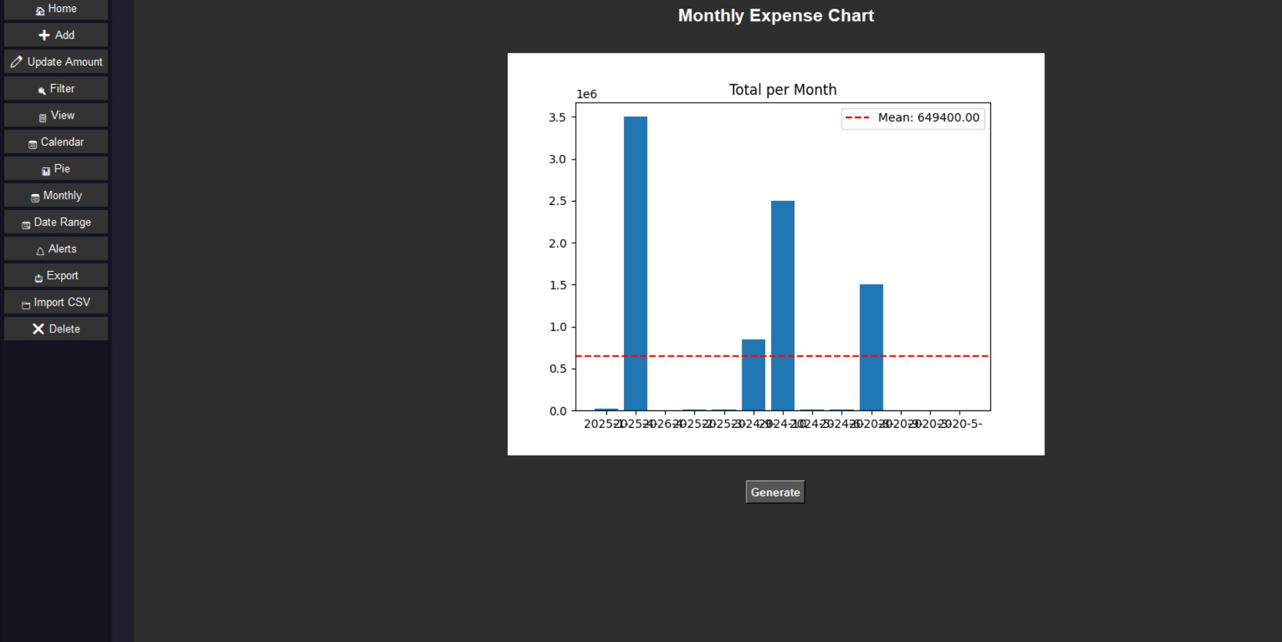
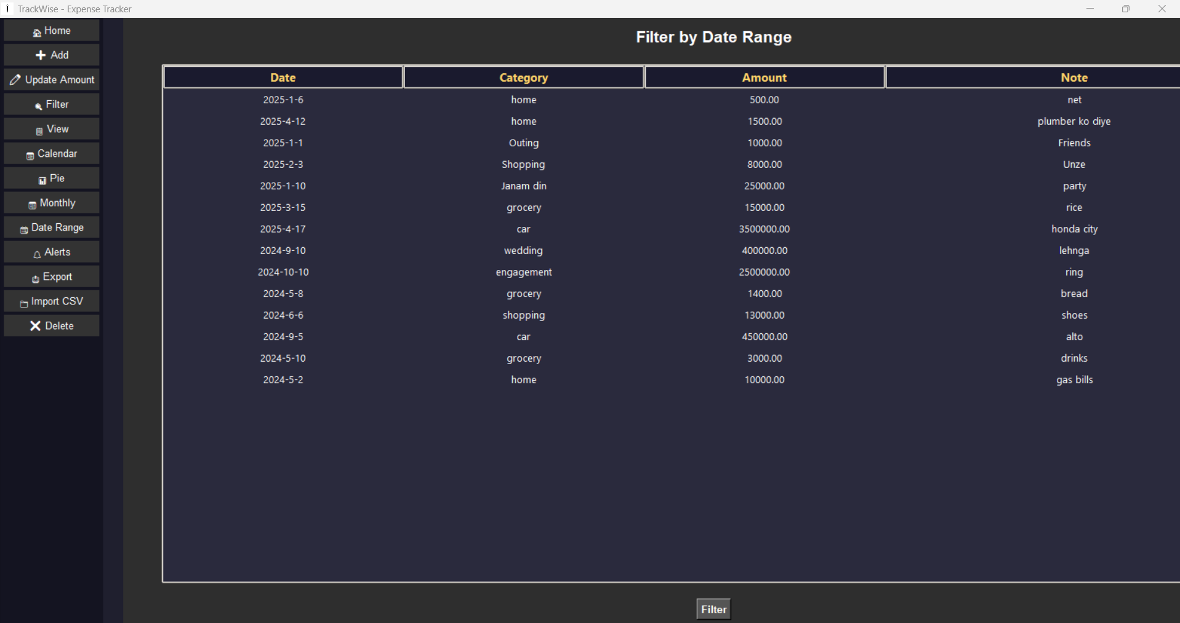
I have entered a wider range and this shows the data between it
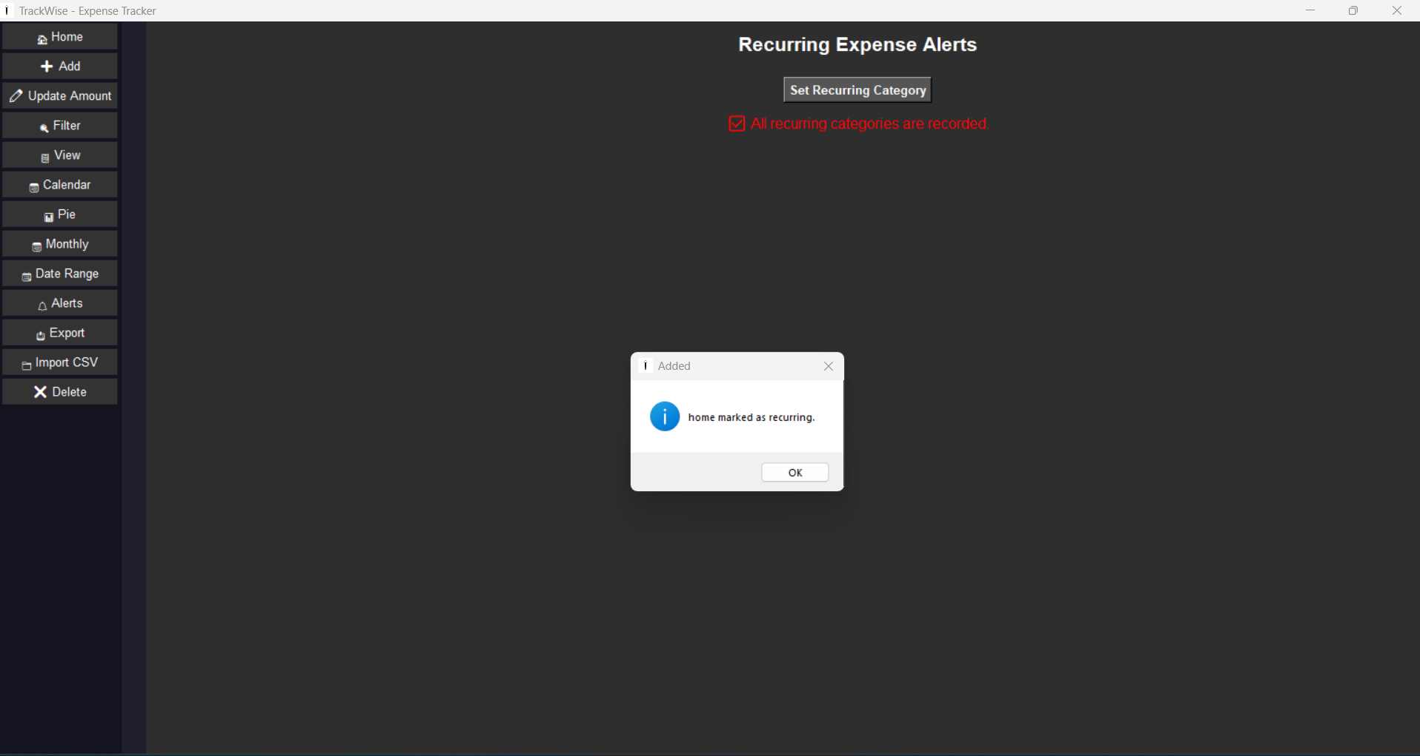
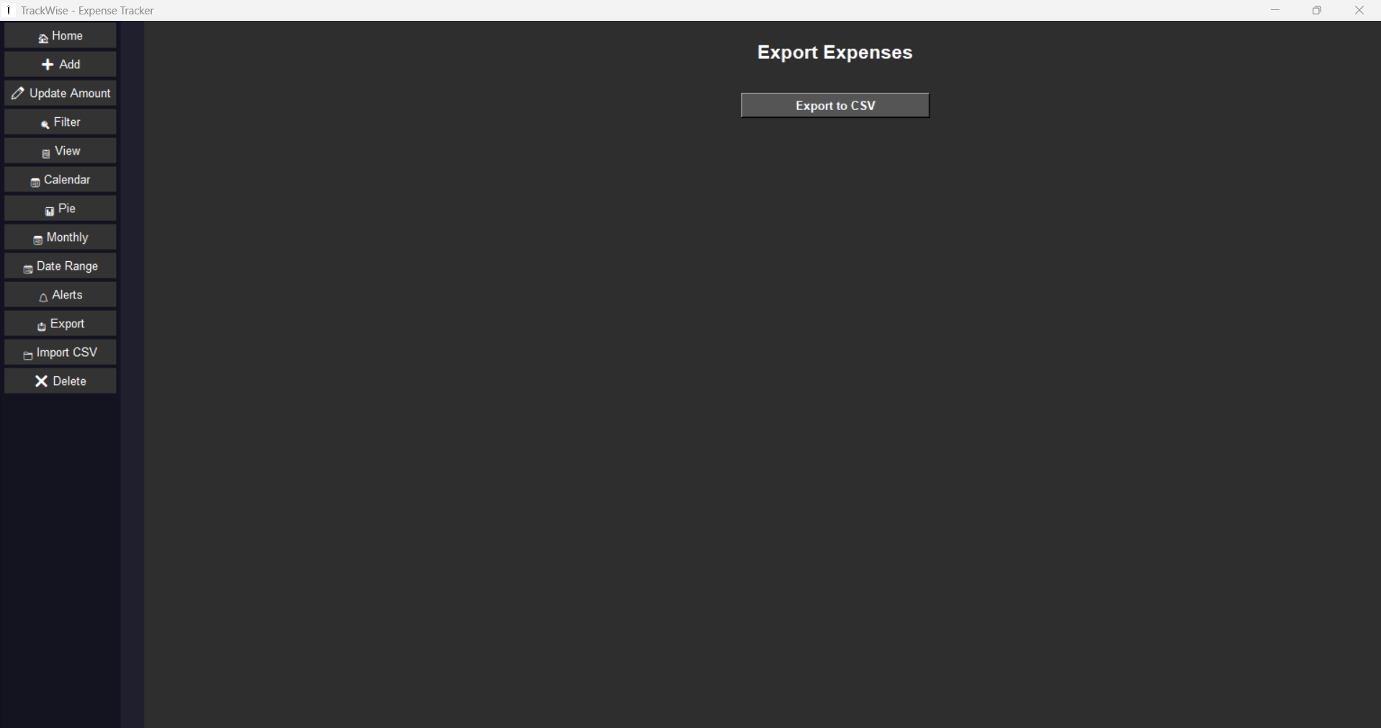
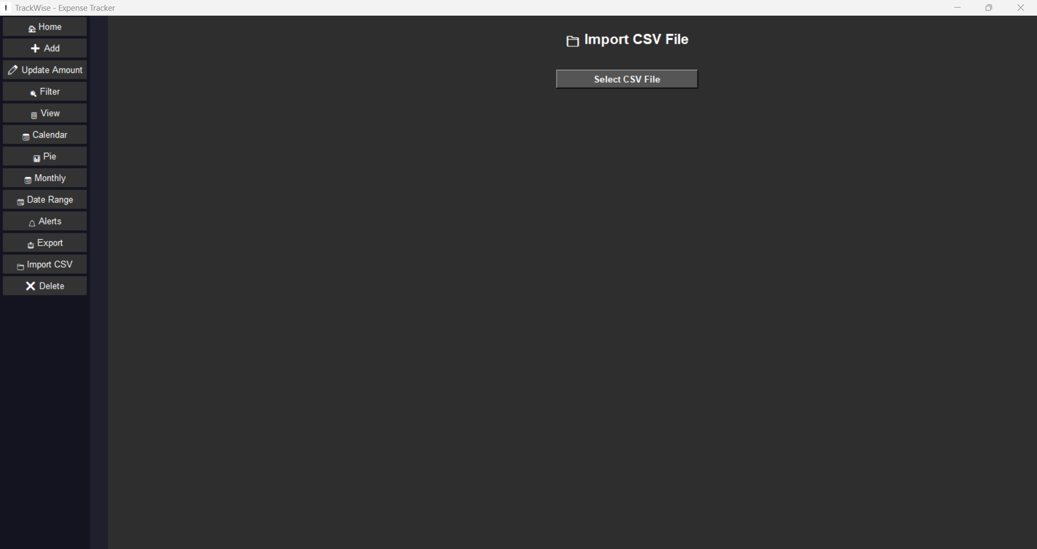
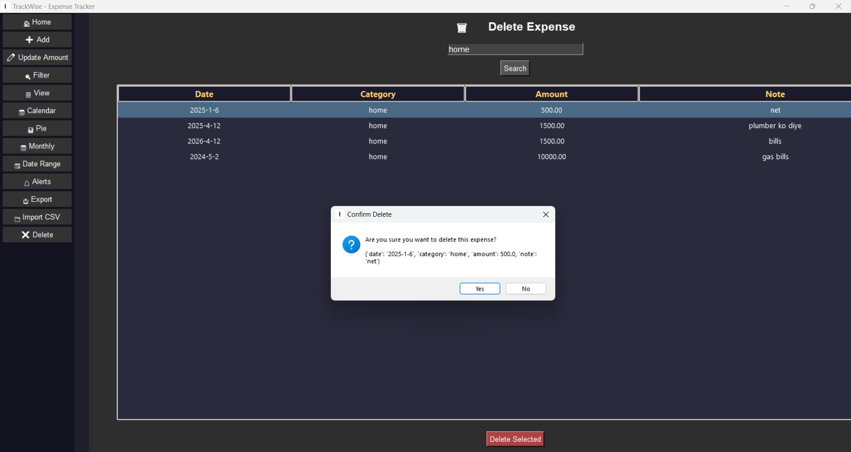
If I Ok this will delete the selected expense
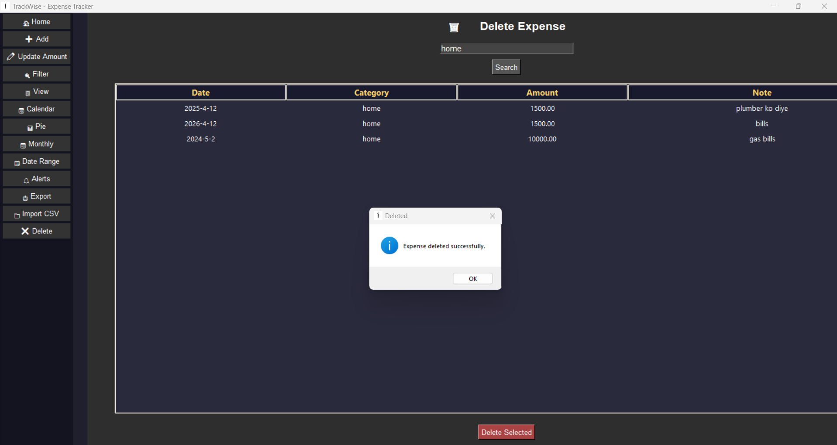

Note:
With this word file I am also attaching a demo CSV and the Ipynb file of my code in the form of a Zip file

Thank You

